Network Script
- First we are going to disable the vibir0 network interface on Centos this will allow our code to work in centos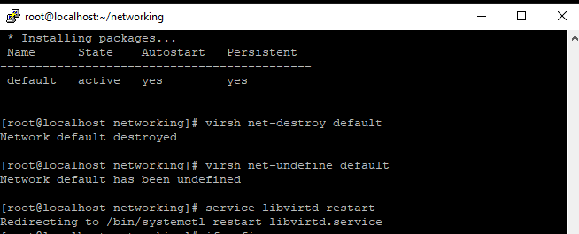
- We are going to be making a script that allows you to dump network information onto the command line and it will also save that information into a text file. The first thing I made sure of is that all the commands I was going to be using was installed and functioning. The commands that I will be using in this script will be Ifconfig, nmap, nano, and ping. Since nmap wasn’t installed on my ubuntu virtual machine I used the command sudo apt-get install nmap. For the CentOS server the commands are slightly different I used sudo yum install nmap. This allowed nmap to be installed. I also had to install nano just for my CentOS sever, to do so I used the command yum install nano.
- After I’ve checked that the following commands were installed and was working then I was ready to connect to my virtual machine remotely using putty. Once I was connected to both virtual machines remotely using putty, I then went into my Centos remote window and used the command su – root to change into root. After I changed into root, I created a directory called networking. To create a directory I used the command mkdir followed by the name you want to call this directory.
- Once I have created my networking directory, I then changed directories into the networking directory by using the cd followed by the name of the directory you have created. As you can see in the image below 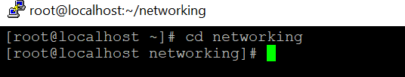
- After I changed into the directory I created, I then used the command nano to create a script file called netscripting in my created directory. As soon as you use the nano command followed by the name of the script you picked it will create it and open it up. Once nano has created and opened the script file, we are going to start by adding the path to bash at the top of the page which is #!/usr/bin/bash. This path will allow you to run the script through a bash session. 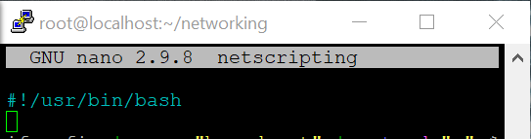
- After the bash path is inserted, then we are ready to start adding our network information commands into the script. The first command I started with was ifconfig. Ifconfig is used to see the network interface and to also configure it. As you can see below it shows my server address (192.168.241.132). 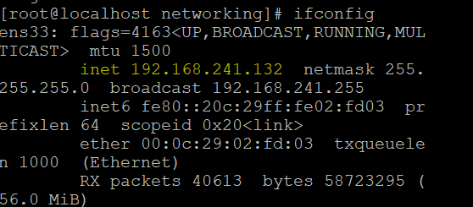now for the ifconfig we do not need all the extra information shown we only want the command to grab the first three octets from the Ip address in my case it’s (192.168.241). To do so we need to use the ifconfig and pipe it using grep followed by the name “broadcast”. This will search for anything in ifconfig that has the word broadcast in it as shown below.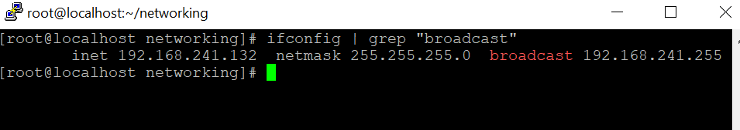
Now we still need to display only the first three octets of the Ip address, so we are going to use ifconfig | grep "broadcast" and pipe this command using cut, Cut is used to cut out parts from a certain line. In this case I used ifconfig | grep “broadcast” | cut -d " " -f 10. As you can see below it just printed out the IP address meaning we are still not done.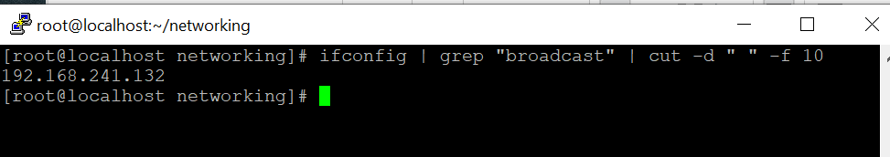since we still want the first three octets we are going to take the above command and pipe it again and use cut -d “.” -f 1,2,3 | uniq. What this part does is that it takes the Ip address and just reads out the first three octets which is represented by the “-f 1,2,3” in the command after we pipe it again and use the command uniq. Uniq is used to filter out repeated lines. As you can see below it just printed out the first three octets in the IP address. 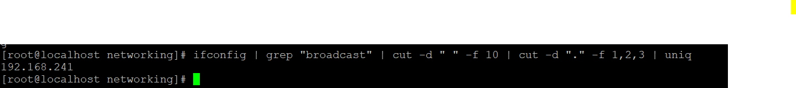
- Now that we have figured out the Ifconfig command the prints only the first three octets of the IP, let’s insert it into the script file under the bash path. At the end of the command you want to add > and the name of a text file you want this information to be saved in. In my case I used address.txt, so this would put the first three octets we found into a text file and save it.
- Next, we want to give the text file we created for the Ifconfig command a variable. To do this we are start with a variable name I used ADDRESS in all caps after you select a name for your variable you are going to use =$(cat address.txt). this is useful because you can just use the new variable text file for the remainder of the other commands. After the variable is created we want it to print out and display that information. To do this we are going to use the echo command. So we are going to echo “” > $ADDRESS.txt, this means to echo the blank space to the information stored in $ADDRESS.txt allowing you to display the three octets in the IP address.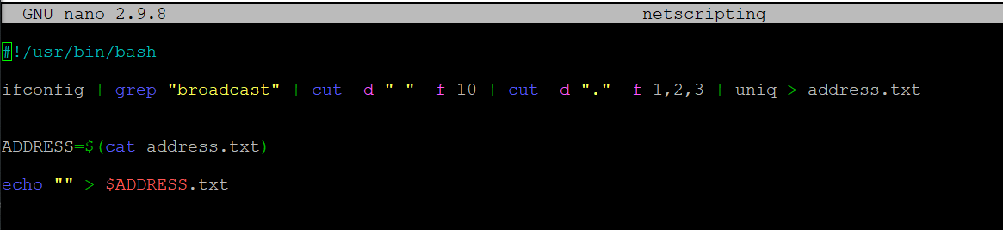
- Next, we are going to create a ping loop for our script that displays any addresses that begins in 192.168.241 being pinged to our server. We are going to use the for command to create our loop. The for command is used to repeatedly execute a set of command. In this case we want to use for ip in {1..254} next you want to click enter and on the next line insert do, click enter again then hit the tap key to indent. Next we are going to add our ping command to our loop. Where you inserted the indent type ping -c 1 $ADDRESS.ip | grep “64 bytes” | cut -d “ “ -f 4 | tr -d “:” >> $ADDRESS.txt &. Basically this command takes any ip address that starts with 19.168.241 that are pinging to the server. Next it will grep anything that starts with “64 bytes”. Now we have to cut it so that only the IP addresses that are pining is displayed by using the cut command after we use the cut command we are going to pipe tr -d “:” command this means to delete anything after the “ : “ , then we are going to append this information to $ADDRESS.txt &. After hit enter and insert done to end the loop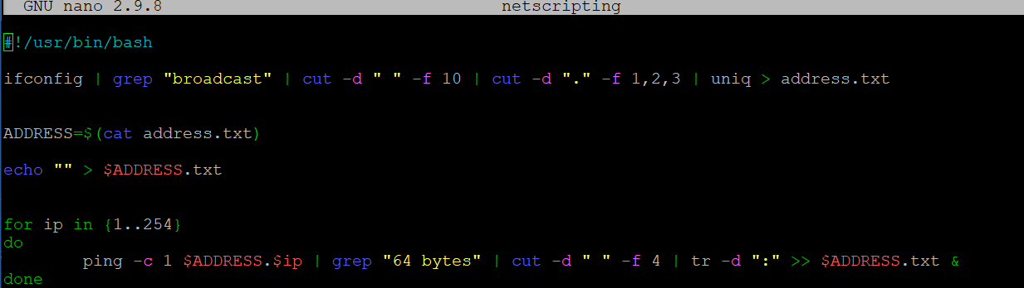
- Next, we are going to display our results to the ping loop buy using the command cat. So we are going to cat $ADDRESS.txt | sort > ping_$ADDRESS.txt. we took all the ip addresses that were pinged form $ADDRESS.txt and sorted it into a new file called Ping_$ADDRESS.txt. The sort command is used to sort a files record in a certain order. 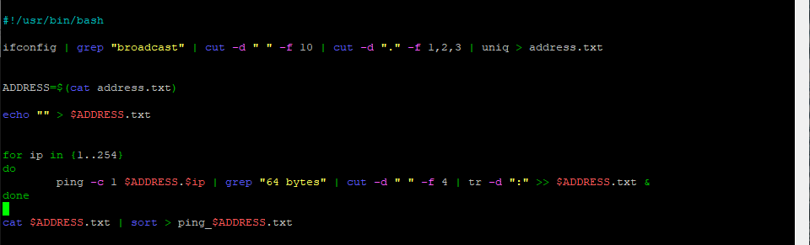
- Now we are going to nmap all the pinged IP addresses simultaneously. To do so we are going to nmap -sS -iL ping_$ADDRESS.txt. For this command we are going to use the file that is sorted which is ping_$ADDRESS.txt. 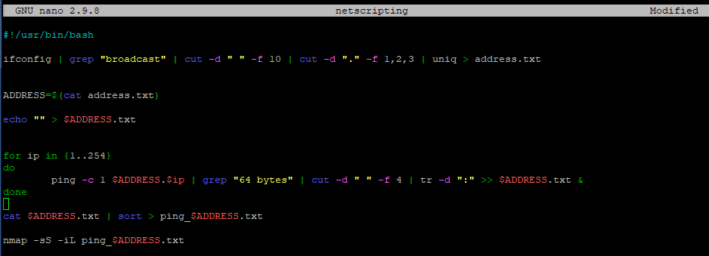
- For this last part we are going to add the command to find the DNS address and also print the result. We are going to start with less /etc/resolv.conf , this command shows you the servers dns. Next we are going to add the result of “less /etc/resolv.conf” into a file called dns.txt by using less /etc/resolv.conf > dns .txt. now we want to display the result by using cat dns.txt. Next hit enter and type exit. 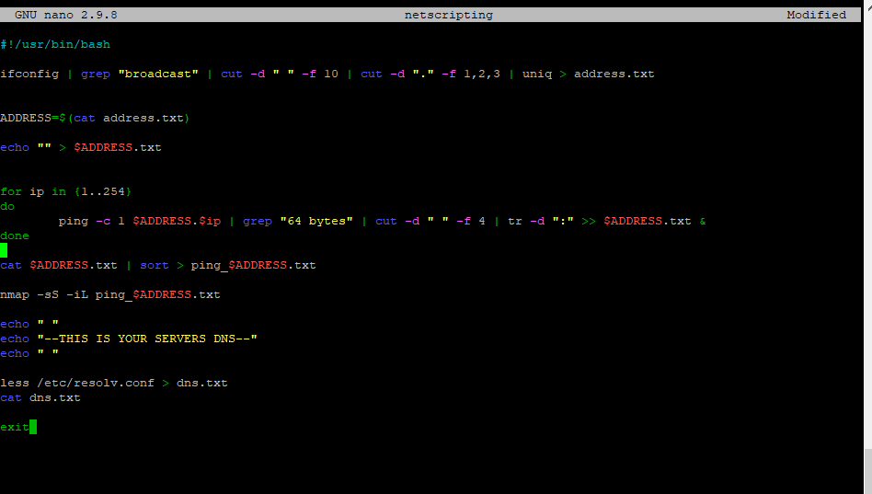
- Next you going to want to hit ctrl s to save the file and then hit enter to continue. Now we have to give the script we just created executable permission by using the command chmod +x netscripting. To see if the permission worked us ls in the directory the file is in, the name of the script should light up a different color. To run the file simple use ./netscripting .
- Now we are going to send the a copy of the directory we created to put the script file in, and everything else inside the directory to our other server scp -r /root/networking 192.168.241.135:/root. We will be sending it to the other server in the root user. Now if you go into root on your other server remotely through putty and use ls you should see the directory you sent. Cd into the directory you sent and if to ls the script file should be in there. 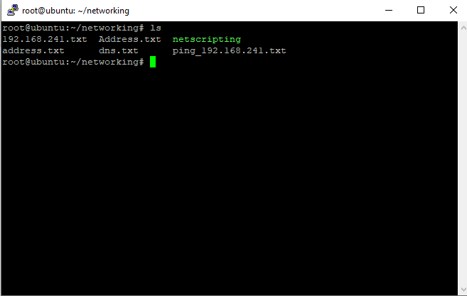now run the script using command using ./

